Misr University for Science and Technology

College of Information Technology

A Graduation Project Report Submission in Partial Fulfillment of the Requirements for the award of the degree

Bachelor of Information Technology

FAIR: A Computer Vision System for Fair Talent Discovery

Under Supervision of

Prof. Dr. Elsayed Badr  
T.A Aya Taha

Jan 2025

Misr University for Science and Technology

College of Information Technology

Bachelor of Information Technology

**FAIR: A Computer Vision System for Fair Talent Discovery**

Submitted by

*Student ID Dept.*

*Shahd Hatim 200018584 CS*

*Nader Mamdouh 200013285 CS*

*Omar Hamada 200013280 CS*

*Mahmoud Kolib 200018343 CS*

Under Supervision of

Prof. Dr. Elsayed Badr  
T.A Aya Taha

JAN 2025

**ABSTRACT**

The traditional athletic tryout process in Egypt faces significant challenges, including overcrowded events, limited time and attention from scouts, and high costs for participants. These barriers often result in overlooked talent and inefficiencies in talent identification. This project introduces Talent Vision, an innovative platform designed to modernize the scouting process and provide equal opportunities for athletes to showcase their abilities. By leveraging technology, Talent Vision offers features such as virtual tryouts, athlete profiles, and advanced scout tools to create an inclusive, efficient, and merit-based system. This platform aims to bridge the gap between athletes and scouts, foster talent development, and contribute to a more dynamic and equitable sports industry.

Acknowledgment

We would like to express our deepest gratitude to all individuals and organizations who have contributed to the development of this project. To our mentors and advisors, thank you for your guidance, valuable insights, and continuous support throughout this journey. To our peers, thank you for your constructive feedback and encouragement, which have helped refine our vision and approach. We also extend our appreciation to the young athletes and scouts who shared their experiences and challenges, enabling us to design a solution tailored to their needs. Finally, we are grateful to our families and friends for their unwavering belief in us, providing the motivation and strength to pursue this initiative. This project is a testament to the collective effort and dedication of everyone involved, and we sincerely thank you for being part of this journey.

**TABLE OF CONTENTS**

ABSTRACT I  
ACKNOWLEDGMENT II

LIST OF TABLES V

LIST OF FIGURESVI

LIST OF SYMBOLS AND ABBREVIATIONSVII

CHAPTER 1: INTRODUCTION 1

1.1 Overview 2

1.2 Motivation2

1.3 Problems Definition2

1.4 Objectives2

1.5 Thesis Structure 2

**CHAPTER 2: RELATED WORKS**3

2.1 Related Work 4

2.1.1 Objectives 5

2.1.2 Development tools 6

2.1.3 Advantages 7

2.1.4 Disadvantages8

2.2 The proposed System8

2.2.1 Objectives & system functionalities8

2.2.3 Advantages9

2.3 Comparison between related work & the proposed system10

**CHAPTER 3: SYSTEM DEVELOPMENT METHODOLOGY11**

3.1 Software Process Model**12**

3.1.1 Software Process Model Name **12**

3.1.1.1 Overview **12**

3.1.1.2 Steps **12**

3.1.1.3 Strength **12**

3.1.1.4 Weakness **12**

3.1.1.5 Why do we use this model?**12**

3.2 Project Plan (Gantt Chart)**12**

**CHAPTER 4: SYSTEM ANALYSIS AND DESIGN13**

4.1 System Domain 14

4.2 Requirements Specification 14

4.2.1 Functional Requirements 14

4.2.2 Non-Functional Requirements 14

4.3 UML Diagrams 14

4.3.1 Context Modeling 14

4.3.1.1 Context Diagram 14

4.3.2 Interaction Modeling 14

4.3.2.1 Use Case Description 14

4.3.2.2 Use Case Diagram 14

4.3.2.3 Sequence Diagram14

4.3.3 Structural Modeling 14

4.3.3.1 Class Diagram 14

4.3.4 Behavioral Modeling 14

4.3.4.1 Event-Driven Modeling14

4.3.4.1.1 State Diagram14

4.3.4.2 Data-Driven Modeling14

4.3.4.2.1 Activity Diagram14

4.3.4.2.2 DFD Level 014

4.3.4.2.3 DFD Level 114

4.3.4.2.4 Data Dictionary14

4.3.5 Data Modeling 14

4.3.5.1 Database Schema14

4.3.5.1 Entity-Relationship Diagram14

4.4 System Architecture14

4.5 UI/UX Design14

Chapter 1

Introduction

**CHAPTER 1: Introduction**

* 1. **Motivation**

Egypt is home to a wealth of young, untapped athletic talent that often goes unnoticed due to systemic inefficiencies in the current tryout process. This immense pool of potential remains largely unutilized, not because of a lack of skill or dedication, but due to barriers that prevent fair opportunities for exposure. Overcrowded tryouts, the limited time and attention of scouts, and the prohibitive costs of participating in these events create a system that hinders athletes from showcasing their true abilities and scouts from identifying the best talent.

These systemic issues result in frustration for both parties. Talented young athletes, brimming with potential, often see their dreams slip away due to circumstances beyond their control. At the same time, scouts and sports organizations struggle to efficiently identify and recruit promising individuals, leaving gaps in their teams and programs. The current process is not only inefficient but also inherently exclusive, favoring those who have access to financial resources and connections over those who might possess genuine skill and dedication.

At Talent Vision, we envision a future where every young athlete, regardless of their socioeconomic background, has an equal opportunity to shine. Our mission is to revolutionize the scouting process by introducing innovative, technology-driven solutions that make talent recognition more inclusive, efficient, and merit-based. By empowering athletes to showcase their skills in a structured and accessible manner, we aim to bridge the gap between potential and opportunity.

Talent Vision will leverage modern tools and platforms to create a system that works for everyone. By streamlining the scouting process, reducing costs, and ensuring that every athlete gets a fair chance to be seen, we hope to foster a culture that values hard work, talent, and determination. Our motivation stems from a deep belief in the transformative power of sports to shape lives and communities.

Through Talent Vision, we aspire to unlock the full potential of Egypt's youth, contributing to the development of a thriving athletic ecosystem where talent is recognized, nurtured, and celebrated. Together, we can create a brighter future for young athletes and pave the way for a more equitable and dynamic sports industry.

* 1. **Problem Definition**

The current athletic tryout process is fraught with inefficiencies and barriers that significantly limit its ability to identify and nurture promising talent. These issues not only hinder the development of athletes but also challenge scouts and sports organizations in building effective teams. The key problems can be outlined as follows:

**1.2.1 Overcrowded Tryouts**

The sheer volume of athletes attending tryouts creates a chaotic environment that makes it difficult for scouts to thoroughly evaluate each participant. Thousands of hopeful athletes compete for limited attention, leading to rushed assessments and missed opportunities to identify genuine talent. Many potential stars remain undiscovered, not because they lack ability, but because the system cannot adequately accommodate the large number of participants. This overcrowding diminishes the overall quality and fairness of the tryout process, leaving both athletes and scouts dissatisfied.

**1.2.2 Limited Attention**

Scouts are often pressed for time and face the overwhelming task of assessing a high volume of athletes within a constrained timeframe. This results in evaluations that may be incomplete, inconsistent, or biased. Promising athletes may be overlooked simply because scouts are unable to give each individual the attention they deserve. The lack of comprehensive evaluation not only affects athletes but also impacts the overall quality of teams and sports organizations, which miss out on recruiting top-tier talent.

**1.2.3 Costly and Exhausting Process**

Participating in the traditional tryout process places a significant financial and emotional burden on athletes and their families. Traveling to tryouts, covering accommodation expenses, and handling other associated costs can be prohibitively expensive, particularly for those from underprivileged backgrounds. Additionally, the physical and mental toll of attending multiple tryouts in different locations can leave athletes fatigued and stressed, negatively affecting their performance. This unfairly disadvantages talented individuals who lack the resources to fully participate, perpetuating inequalities in the sports industry and limiting the pool of available talent.

* 1. **Objectives**

Talent Vision combines its objectives with innovative features to address the inefficiencies of traditional tryouts and modernize the scouting process:

1.3.1 **Revolutionize Talent Discovery with Video Upload & Analysis:** Athletes can record and upload videos of their skills and performance, eliminating the need for physical tryouts. This ensures that all athletes have equal opportunities to be seen by scouts.

1.3.2 **Democratize Access Through Multi-Sport Support:** The app supports multiple games, ensuring inclusivity across various athletic disciplines. Every athlete, regardless of location or financial status, can participate in the scouting process.

1.3.3 **Enhance Evaluation Accuracy with Performance Feedback Using AI:** The app employs AI algorithms to analyze video footage, providing scouts with objective insights into an athlete’s technique, potential, and areas for improvement. This technology eliminates bias and enhances the accuracy of evaluations.

1.3.4 **Foster Growth Through Progress Tracking:** Athletes can monitor their development over time through data-driven insights, helping them identify strengths and areas to work on. This feature helps athletes stay motivated and continuously improve.

1.3.5 **Promote Collaboration with Professional Insights:** Collaborations with professional coaches and athletes enable the app to provide valuable feedback and guidance, fostering growth and development among young athletes.

* 1. **Thesis Structure**
* **Chapter 1: Introduction** This chapter provides an overview of the project, the motivation behind it, the problem definition, and the objectives. It also outlines the structure of the thesis.
* **Chapter 2: Related Works** presents a review of previous related works, such as Hudl, Coach's Eye, Dartfish,Homecourt (Basketball Focused),Trace Soccer, NEX Team (Game-Level AI Analysis), OpenScout (Football Talent Discovery),and Sportlogiq, along with a comparison of their features and limitations compared to the proposed system. It also discusses a survey conducted to gather user opinions and requirements for the platform.
* **Chapter 3: System Development Methodology** covers the software development life cycle, and the process model used for the project, concluding with a detailed time management plan for the development stages.
* **Chapter 4: System Analysis and Design** highlights the analysis and design phase. This chapter includes the use of analysis techniques to clarify system requirements through diagrams that represent how the system works and define the roles of system users. It also introduces the system’s architecture through UML diagrams, providing detailed explanations of each
* **Chapter 5: Focuses on the implementation phase** discussing the tools, technologies, and programming languages used to develop the system
* **Chapter 6: presents the results of the system** including testing, feedback, and evaluation, along with future recommendations

Related Works

Chapter 2

**CHAPTER TWO: Related Works**

2.1 Hudl

2.1.1 Objectives

Provide athletes with a platform to upload and share gameplay videos.

Enable coaches to analyze player performance and create highlight reels.

Facilitate collaboration between teams, athletes, and scouts.

2.1.2 Development Tools

* Backend: Python, Node.js.
* Frontend: React.js.
* Video Processing: FFmpeg.
* Cloud Storage: AWS for scalable video storage and retrieval.
* AI/ML: Custom-built algorithms for video tagging and analysis.

2.1.3 Advantages

* Comprehensive platform for video analysis and sharing.
* Widely used by professional and amateur athletes alike.
* Strong focus on team collaboration.

2.1.4 Disadvantages

* Primarily focused on team sports like football and basketball.
* Requires subscription fees, limiting accessibility for underprivileged athletes.

2.2 Coach's Eye

2.2.1 Objectives:

* Offer athletes and coaches a tool for slow-motion video review.
* Improve technical feedback through video annotations and analysis.

2.2.2 Development Tools:

* Mobile App Framework: Swift (iOS) and Kotlin (Android).
* Video Playback: OpenGL for frame-by-frame analysis.
* Cloud: Google Firebase for data storage and sharing.

2..2.3 Advantages:

* User-friendly interface with powerful video annotation tools.
* Great for individual feedback during training.

2.2.4 Disadvantages:

* Limited to video analysis without AI insights.
* Requires manual annotations, which can be time-consuming.

2.3 Dartfish

2.3.1 Objectives:

* Provide athletes and coaches with video tagging and motion analysis.
* Enable data-driven feedback for performance improvement.

2.3.2 Development Tools:

* Video Analysis: Custom algorithms for motion tracking.
* Data Storage: On-premise and cloud-based storage options.
* Cross-platform App Development: Java and C#.

2.3.3 Advantages:

* Highly detailed analysis, especially useful for technical sports.
* Supports tagging specific moments in videos for precise feedback.

2.3.4 Disadvantages:

* Expensive and targeted towards professional sports organizations.
* Steeper learning curve for new users.

2.4 HomeCourt (Basketball Focused)

2.4.1 Objectives:

* Use AI to analyze basketball training sessions and provide performance feedback.
* Track stats like shooting accuracy, speed, and positioning.

2.4.2 Development Tools:

* AI Frameworks: TensorFlow and PyTorch for motion detection.
* Video Processing: OpenCV.
* Cloud Infrastructure: Google Cloud for real-time processing.

2.4.3 Advantages:

* Highly specialized for basketball players.
* Real-time AI-based performance analysis.

2.4.4 Disadvantages:

* Restricted to basketball; not suitable for other sports.
* Requires high-quality cameras for accurate analysis.

2.5 Trace Soccer

2.5.1 Objectives:

* Use wearable technology and video analysis to track player movement during soccer games.
* Provide coaches with detailed game and performance insights.

2.5.2 Development Tools:

* Hardware: Proprietary wearables for movement tracking.
* Software: AI for player positioning and game event detection.
* Integration: Mobile app for data visualization (React Native).

2.5.3 Advantages:

* Combines wearable tech and AI for accurate performance tracking.
* Provides actionable insights for team tactics and player improvement.

2.5.4 Disadvantages:

* Relies on expensive wearable devices.
* Limited to soccer; not adaptable to other sports.

2.6 NEX Team (Game-Level AI Analysis)

2.6.1 Objectives:

* Use AI to provide game-level performance analysis and feedback.
* Enhance individual athlete development through video-based insights.

2.6.2 Development Tools:

* Video AI: Deep learning models for skill recognition.
* Backend: Python Flask/Django for API development.
* Frontend: React.js.

2.6.3 Advantages:

* Effective AI integration for skill evaluation.
* Focuses on individual growth and technical improvements.

2.6.4 Disadvantages:

* Currently limited to specific sports like basketball.
* Requires high-quality video inputs for accurate results.

2.7 OpenScout (Football Talent Discovery)

2.7.1 Objectives:

* Allow athletes to upload videos showcasing their skills for scout evaluations.
* Create a platform that connects players directly with professional scouts.

2.7.2 Development Tools:

* Cloud: AWS for video storage and processing.
* Frontend: Angular.js.
* AI Integration: Basic computer vision models for skill tagging.

2.7.3 Advantages:

* Accessible platform for young athletes to reach scouts.
* Focused on connecting talent with professional opportunities.

2.7.4 Disadvantages:

* Narrow focus on football.
* Relatively basic AI features compared to other platforms.

2.8 Sportlogiq

2.8.1 Objectives:

* Use AI and computer vision to provide advanced analytics for professional teams.
* Track player movements and actions in real-time.

2.8.2 Development Tools:

* AI/ML: Deep learning models for motion tracking and event detection.
* Cloud: Azure for scalable data processing.
* Video Processing: High-performance frameworks like FFmpeg and OpenCV.

2.8.3 Advantages:

* Highly detailed insights for professional-level gameplay analysis.
* Focuses on tactical and technical aspects of performance.

2.8.4 Disadvantages:

* Requires high-quality video feeds for accurate analytics.
* Limited to professional use; not accessible for young athletes.
  1. **A Questionnaire for End Users**

The following questionnaire is designed to understand the needs, preferences, and challenges faced by players and coaches. The responses will guide the development and optimization of the application.

* + 1. The questions:

What is your primary sport?

* Football
* Basketball
* Handball
* Tennis
* Other [……]

How often do you practice or train?

* 3-4 times a week
* 1-2 times a week
* Rarely

What is your current level of play?

* Beginner
* Intermediate
* Professional

What areas of your performance would you like to analyze? (Select all that apply)

* Speed
* Insurance/Stamina
* Technique/Form
* Reaction
* Accuracy

How do you currently track your performance?

* I don't track my performance
* Manually
* With wearable devices
* Using App

Would you be interested in setting goals within the app and tracking progress toward them?

* Yes
* No
* Maybe

Which features would you find most useful in a sports analysis app?

* Personalized training plans
* Video analysis of form and technique
* Performance tracking over time
* Real-time feedback during practice
* Comparison with other players
* Injury prevention tips
* Social sharing and progress updates

How important is it for the app to connect with wearable devices?

Very Important 1 2 3 4 5 Not important

How likely are you to use an app to improve your sports performance?

Very likely 1 2 3 4 5 Very unlikely

What platform do you prefer for using sports analysis apps?

* Smart phones
* Tablets
* Desktop
* Wearable devices

Do you prefer in-app tutorials to help you get started with new features?

* Yes, I find tutorials helpful
* No, I prefer to explore on my own
* It depends on the complexity of the feature
  + 1. Questionnaire Results

Forms response chart. Question title: What is your primary sport?
. Number of responses: 18 responses. 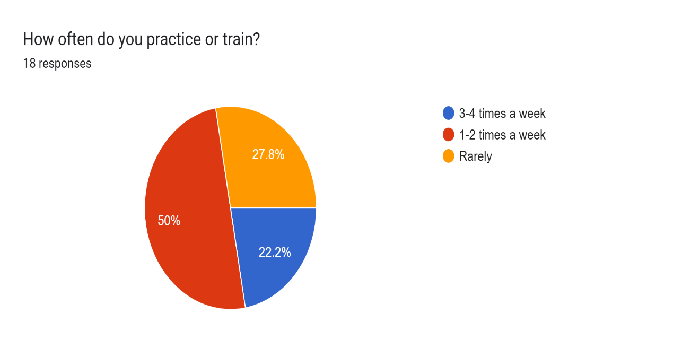

Forms response chart. Question title: What is your current level of play?
. Number of responses: 18 responses.

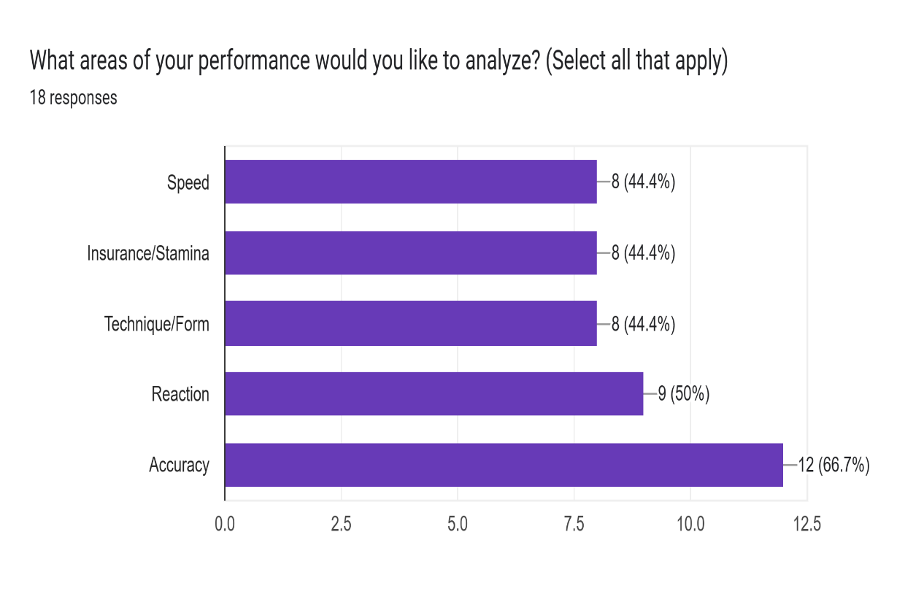

Forms response chart. Question title: How do you currently track your performance?
. Number of responses: 18 responses.

Forms response chart. Question title: Would you be interested in setting goals within the app and tracking progress toward them?
. Number of responses: 17 responses.

Forms response chart. Question title: Which features would you find most useful in a sports analysis app?
. Number of responses: 18 responses.

Forms response chart. Question title: How likely are you to use an app to improve your sports performance?
. Number of responses: 18 responses. Forms response chart. Question title: How important is it for the app to connect with wearable devices?
. Number of responses: 18 responses.

Forms response chart. Question title: What platform do you prefer for using sports analysis apps?
. Number of responses: 18 responses.

Forms response chart. Question title: Do you prefer in-app tutorials to help you get started with new features?
. Number of responses: 18 responses.

Figure 2.1: Questionnaire Results

Chapter 3

**System Development** Methodology

**Chapter 3: System Development Methodology**

**3.1 Software Process Model**

**3.1.1 Waterfall Model**

**3.1.1.1 Overview**

The Waterfall Model is a sequential software development process where progress is seen as flowing steadily downwards (like a waterfall) through several phases. This model was first introduced by Dr. Winston W. Royce in 1970. Each phase must be completed before the next phase begins, and there is no overlapping in the phases. It is a straightforward and disciplined method that follows a top-down approach.

**Figure 3.1: Waterfall Model**

**3.1.1.2 Steps**

1. **Project Initiation**:
   * This is the starting point where the project’s objectives, scope, purpose, and feasibility are determined. This phase is critical for understanding the business case and setting the foundation for the project.
2. **Requirement Analysis**:
   * In this phase, all possible requirements of the system to be developed are captured. These requirements are then documented and reviewed with stakeholders for approval.
3. **UI/UX Design**:
   * Once the requirements are clear, the design phase begins. The system and software design is prepared from the requirement specifications. This phase includes designing the system architecture, user interfaces, and user experiences.
4. **Frontend Development**:
   * This phase involves the actual implementation of the user interface, ensuring that the visual components are developed according to the design specifications.
5. **Backend Development**:
   * The backend of the system is developed during this phase. It includes server-side logic, database management, and integration of various system components.
6. **Computer Vision Model Development**:
   * In this phase, the core computer vision model is developed, trained, and tested. This model will be used for talent discovery in sports as per the project requirements.
7. **Integration and Testing**:
   * After the coding is complete, the developed modules are integrated and tested as a whole to ensure that the entire system works according to the specified requirements.
8. **Deployment and Release**:
   * In this phase, the system is deployed in the real environment. Once the system is fully functional, it is released to the users.
9. **Documentation and Finalization**:
   * Final documentation of the system is prepared. This includes user manuals, system documentation, and final reports.
10. **Presentation and Evaluation**:
    * The final phase involves presenting the developed system to stakeholders and evaluating its performance against the set objectives.

**3.1.1.3 Strengths**

* Easy to understand and use.
* Structured approach provides clarity.
* Milestones are clearly defined and easy to track.
* Works well for projects with well-defined requirements.
* Good for projects where quality is more important than cost or schedule.

**3.1.1.4 Weaknesses**

* Inflexible to changing requirements.
* Late discovery of issues since testing is at the end.
* Risk of system failure if there are flaws in earlier phases.
* Not suitable for projects with high levels of uncertainty or risk.

**3.1.1.5 When to Use the Waterfall Model**

* When requirements are well understood and stable.
* For projects with clearly defined stages and deliverables.
* In situations where a thorough documentation process is required.
* When technology is well known and there is a need for a systematic, sequential approach.

**3.1.1.6 Why We Use the Waterfall Model**

* Provides a disciplined, structured approach.
* Helps in tracking project progress through well-defined milestones.
* Suitable for projects where changes in scope are unlikely.
* Effective for projects with fixed requirements and deliverables.
  1. **Gantt Chart**

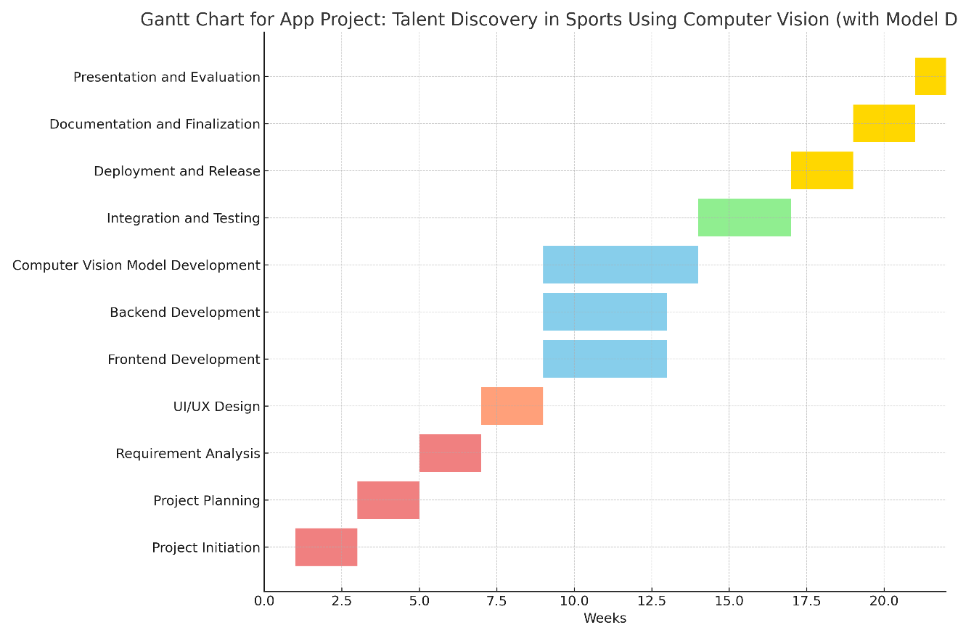

Figure 3.2: Gantt Chart

Chapter 4

System Analysis and Design

**Chapter 4: System Analysis and Design**

* 1. **System Domain**

The Talent Vision platform must cater to the unique needs of the athletic scouting domain by providing a comprehensive and user-friendly environment for both athletes and scouts. The system should enable athletes to create detailed profiles that include personal information, performance videos, statistics, and other relevant metrics, allowing them to showcase their talents effectively. Scouts must be equipped with advanced tools to search, filter, and compare athletes based on various criteria such as sport, position, and performance data, ensuring they can identify the best talent efficiently. To modernize the scouting process, the platform should facilitate virtual tryouts by enabling athletes to upload performance videos and participate in remote evaluations. Furthermore, the system must foster seamless communication between athletes and scouts, providing features like messaging, interview scheduling, and follow-up assessments. A talent ranking or scoring system, built on performance metrics and scout feedback, should also be implemented to ensure a transparent and merit-based evaluation process. By addressing these domain-specific requirements, the platform will create a fair, efficient, and inclusive environment for talent discovery and development.

* 1. **Requirements Specifications**
     1. **Functional Requirements Specification**

These requirements define the specific functionalities the system should provide:

**Athlete-Focused Functionalities**

* Provide athletes with a user-friendly interface to create and manage their profiles.
* Enable athletes to upload performance videos, physical stats, and other achievements.
* Notify athletes about new tryout opportunities or feedback from scouts.

Scout-Focused Functionalities

* Allow scouts to register, create profiles, and define their talent search criteria.
* Enable scouts to review athlete profiles, watch uploaded videos, and assess performance.
* Provide tools for scouts to filter athletes based on various metrics such as location, sport, and skill level.

**Administrative Functionalities**

* Allow administrators to monitor system performance, manage users, and ensure compliance with platform policies.
* Support secure payment processing for premium features or subscriptions.
* Generate analytics and reports for both athletes and scouts to track progress and success rates.

**General Functionalities**

* Ensure seamless onboarding for new users, including tutorials or guides.
* Provide a messaging or communication system for real-time interaction between athletes and scouts.
* Offer multilingual support to cater to diverse user groups.
  + 1. **Non-Functional Requirements**

These requirements define the quality and operational standards of the system:

**Performance**

1. The system must handle at least 10,000 concurrent users without performance degradation.
2. Athlete profile loading times should not exceed 2 seconds under normal conditions.

**Scalability**  
3. The system should be scalable to accommodate future growth in user base and data volume.

**Security**  
4. User data must be encrypted both in transit and at rest.  
5. Ensure role-based access controls to protect sensitive information, such as athlete stats and scout evaluations.

**Availability**  
6. The platform should have an uptime of 99.9%, ensuring reliability for all users.  
7. Provide automatic failover mechanisms to maintain service continuity in case of server failure.

**Usability**  
8. The system should have an intuitive and accessible interface, adhering to universal design principles.  
9. Support mobile and desktop platforms to ensure access across devices.

**Compliance**  
10. The platform must comply with relevant data protection regulations, such as GDPR or local privacy laws.

**Maintainability**  
11. The system should support easy updates and maintenance without significant downtime.  
12. Provide comprehensive documentation for developers and administrators.

**Localization**  
13. The system should support localization to adapt to different languages and cultural contexts.

* 1. **Unified Modeling Language (UML)  
      4.3.1 Context Modeling   
      4.3.1.1 Context Diagram**

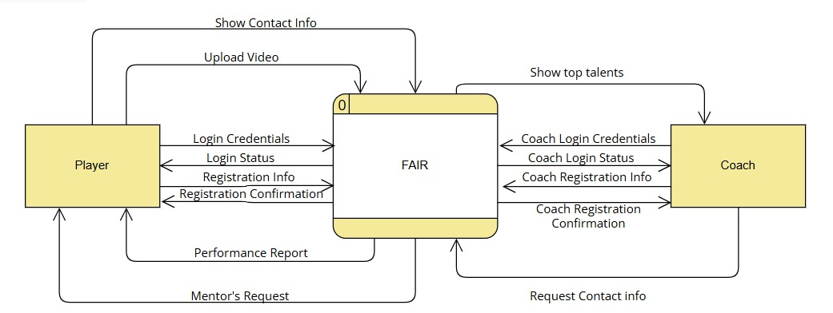

Figure 4.1: Context Diagram

**4.3.2 Interaction Modeling**

**4.3.2.1 Use Case Description**

**Register**

|  |  |
| --- | --- |
| Function Name | Register_user |
| Description | Allows a player or coach to register in the system by providing necessary details. |
| Input | - Full Name  - Email  - Password  - User Type (Player/Coach) |
| Output | - Success message: "Registration Successful!"  - Account created in the system. |
| Action | 1. User navigates to the registration page.  2. The system displays a registration form.  3. User fills in their details (e.g., name, email, password).  4. The system validates inputs for correctness and uniqueness.  5. If validation passes, the system stores the user’s data in the database.  6. The system sends an activation email to the user.  7. User sees a success message: "Registration Successful! Please verify your email." |
| Precondition | - User must provide valid details (unique email, strong password). |
| Postcondition | - User account is created but requires activation (e.g., email verification). |
|  |  |

**Login**

|  |  |
| --- | --- |
| Function Name | login_user |
| Description | Allows a registered user to log in to the system by providing their credentials. |
| Input | - Email - Password |
| Output | - Success message: 'Login Successful!' - Redirect to the user dashboard. |
| Action | 1. User navigates to the login page. 2. System displays a login form. 3. User enters their email and password. 4. System validates the credentials against stored records in the database. 5. If credentials are correct, the system logs the user in and redirects them to the dashboard. 6. If credentials are incorrect, the system displays an error message: 'Invalid email or password.' |
| Precondition | - User must have an active and verified account. |
| Postcondition | - User is authenticated and can access their dashboard and system features. |
|  |  |

**Logout**

|  |  |
| --- | --- |
| Function Name | logout_user |
| Description | Logs the user out of the system and clears their session. |
| Input | None |
| Output | - Success message: 'Logout Successful!' - Redirect to the home page. |
| Action | 1. User clicks the 'Logout' button in the system. 2. System invalidates the user’s session or token. 3. System clears any stored session data (e.g., cookies). 4. User is redirected to the home page with a message: 'Logout Successful!' |
| Precondition | - User must be logged in. |
| Postcondition | - User is logged out, and session data is cleared. |
|  |  |

**Upload Video**

|  |  |
| --- | --- |
| Function Name | upload_video |
| Description | Allows users to upload videos for analysis. |
| Input | - Video file (e.g., MP4, AVI) - Title/Description (optional) |
| Output | - Success message: 'Video uploaded successfully!' - Video saved in the system storage. |
| Action | 1. User navigates to the upload page. 2. System displays an upload form. 3. User selects a video file from their device and optionally provides a title/description. 4. System validates the file type and size. 5. If validation passes, the system uploads and stores the video in the database or file storage. 6. System displays a success message: 'Video uploaded successfully!' |
| Precondition | - User must be logged in. |
| Postcondition | - Video is uploaded and available for analysis. |
|  |  |

**Analyze Video**

|  |  |
| --- | --- |
| Function Name | analyze_video |
| Description | Analyzes the uploaded video for performance metrics. |
| Input | - Video file |
| Output | - Performance metrics (e.g., speed, accuracy). |
| Action | 1. User selects an uploaded video for analysis. 2. System retrieves the video file from storage. 3. System processes the video using video analysis algorithms. 4. System generates a report with key performance metrics. 5. User is presented with the analysis results in the dashboard. |
| Precondition | - Video must be uploaded to the system. |
| Postcondition | - Analysis results are available for viewing and feedback. |
|  |  |

**Provide Feedback**

|  |  |
| --- | --- |
| Function Name | Review Reports |
| Description | Enables coaches to provide feedback on analyzed videos. |
| Input | - Feedback text - Optional attachment (e.g., image, file). |
| Output | - Success message: 'Feedback submitted successfully!' |
| Action | 1. Coach navigates to the analyzed video. 2. System displays a feedback form. 3. Coach enters feedback and optionally uploads an attachment. 4. System validates and stores the feedback in the database. 5. Feedback is linked to the corresponding video and user. |
| Precondition | - Video analysis must be completed. |
| Postcondition | - Feedback is stored and visible to the corresponding user. |
|  |  |

**View Top Players**

|  |  |
| --- | --- |
| Function Name | view_top_players |
| Description | Displays a leaderboard of the top-performing players. |
| Input | None |
| Output | - List of top players with their performance metrics. |
| Action | 1. User navigates to the 'Top Players' page. 2. System retrieves player performance data from the database. 3. System calculates rankings based on predefined criteria. 4. System displays the leaderboard with player details and rankings. |
| Precondition | - Performance data must exist for players. |
| Postcondition | - Leaderboard is displayed with updated rankings. |
|  |  |

**4.3.2.2 Use Case Diagram**

Figure 4.2: Use Case Diagram

**4.3.2.3 Sequence Diagram**

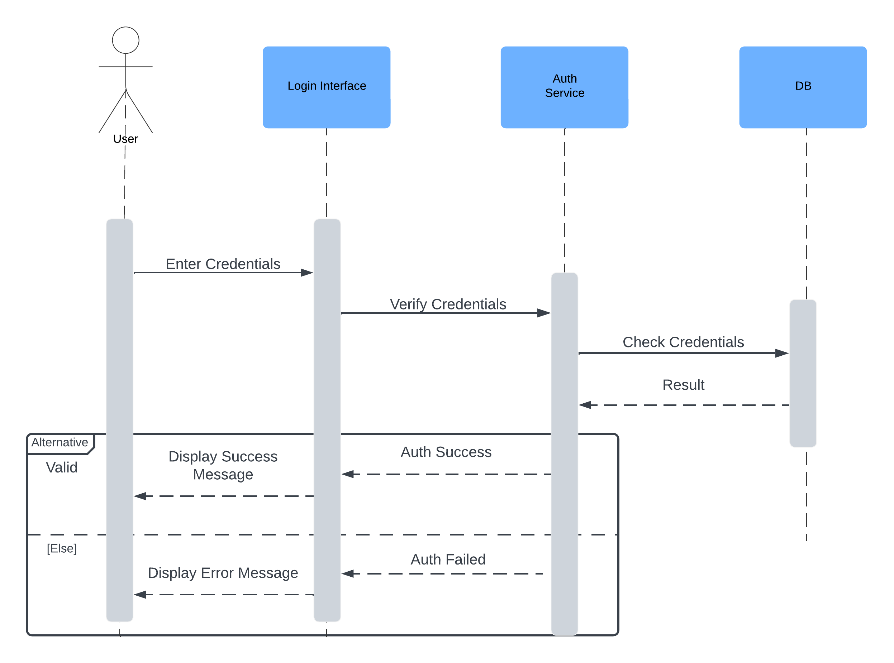

4.16Login Sequence Diagram

4.17Registration Sequence Diagram

4.18view Top Players Sequence Diagram

4.19 Upload Video Sequence Diagram

4.20 Review Report Sequence Diagram

**4.3.3 Structural Modeling**

**4.3.3.1 Class Diagram**

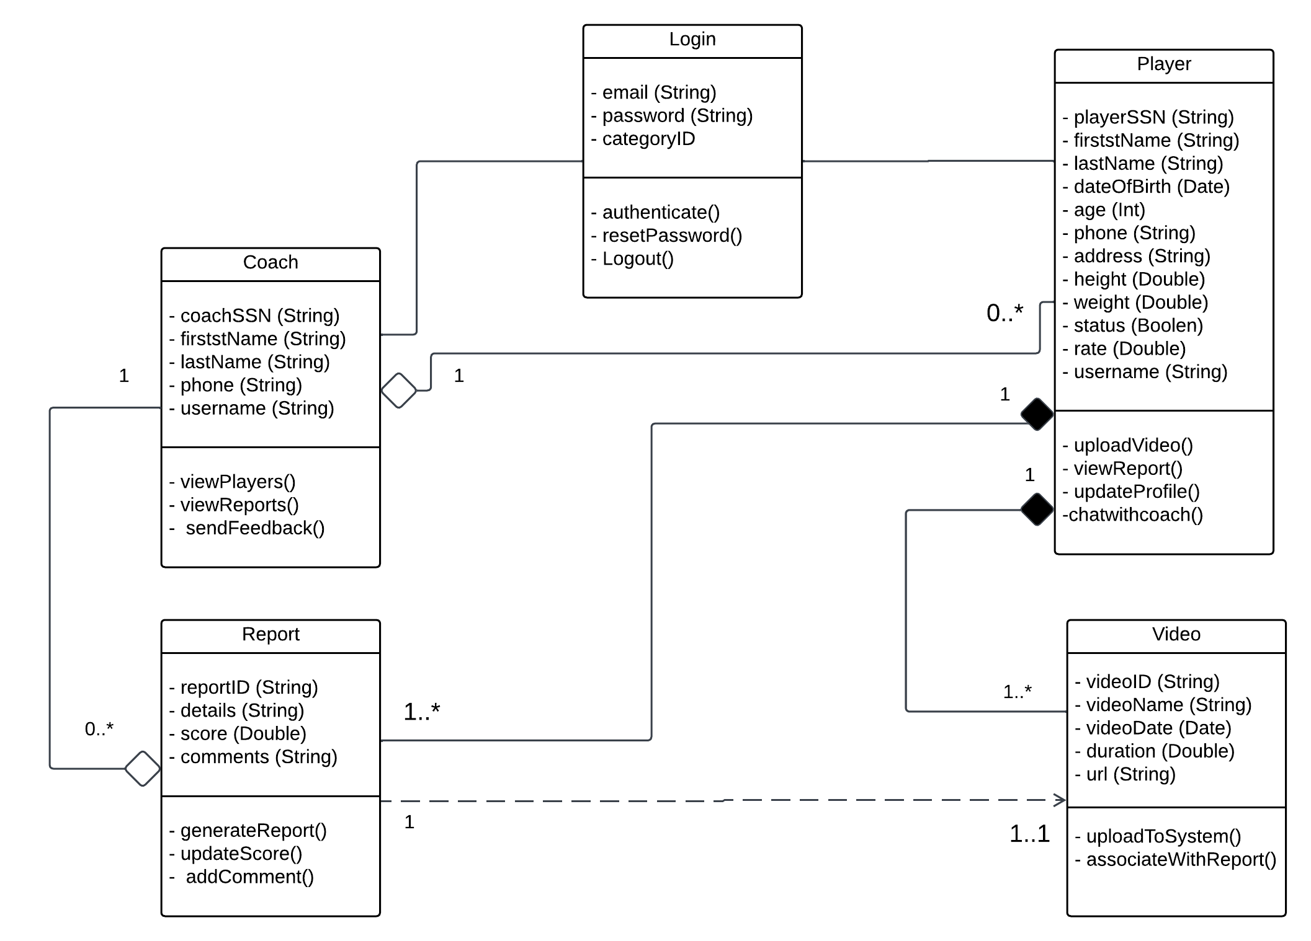

Figure 4.21: Class Diagram

**4.3.4 Behavioral Modeling**

**4.3.4.1 Data-Driven Modeling**

**4.3.4.1.1 Activity Diagram**

Figure 4.22: Activity Diagram

Figure 4.23: Activity Diagram

**4.3.4.2.2 DFD Level 0**

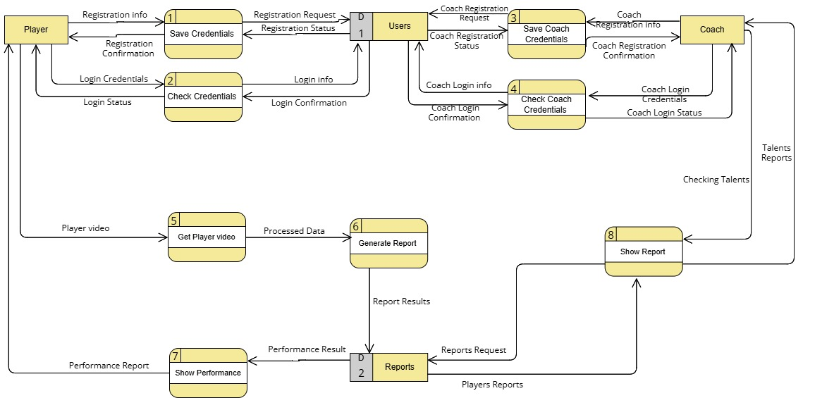 Figure 4.24: DFD Level 0 Diagram

**4.3.4.2.3 DFD Level 1**

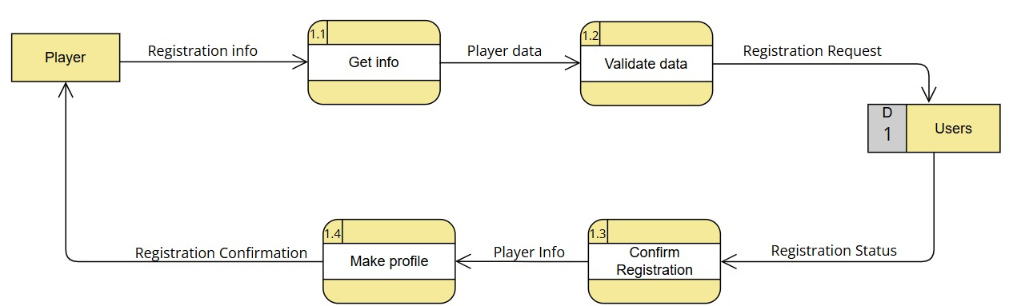

Figure 4.21: DFD Level 1 Diagram

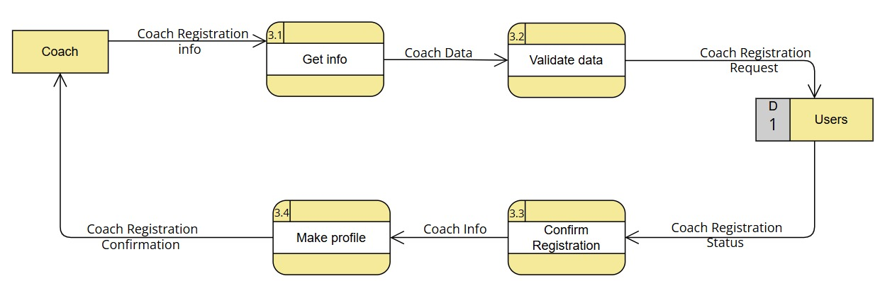

Figure 4.25: DFD Level 1 Diagram

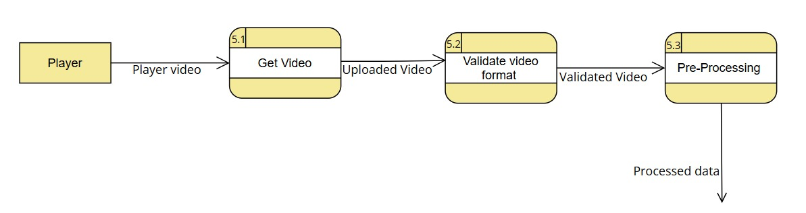

Figure 4.26: DFD Level 1 Diagram

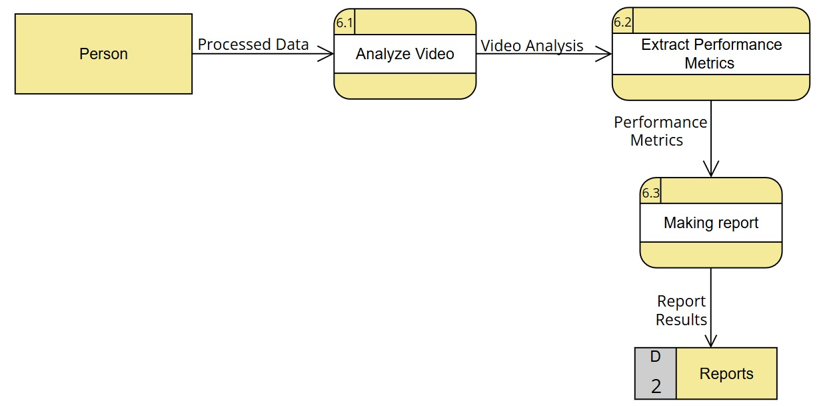

Figure 4.27: DFD Level 1 Diagram

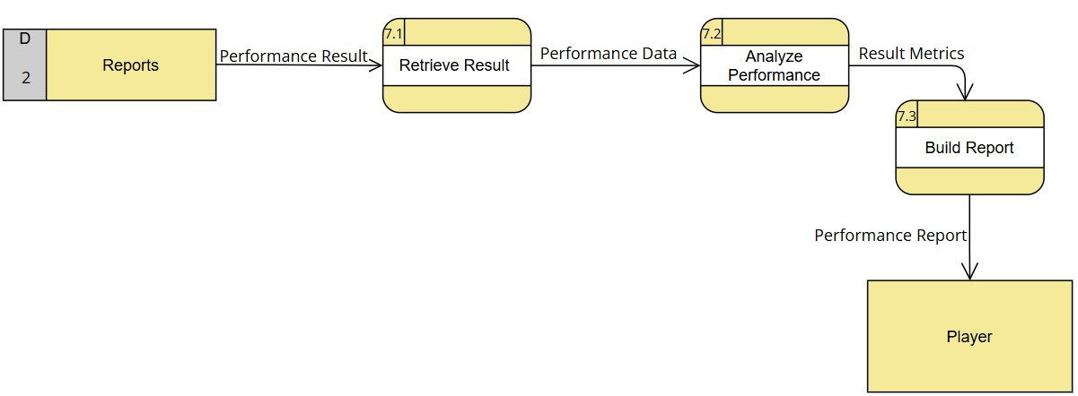

Figure 4.28: DFD Level 1 Diagram

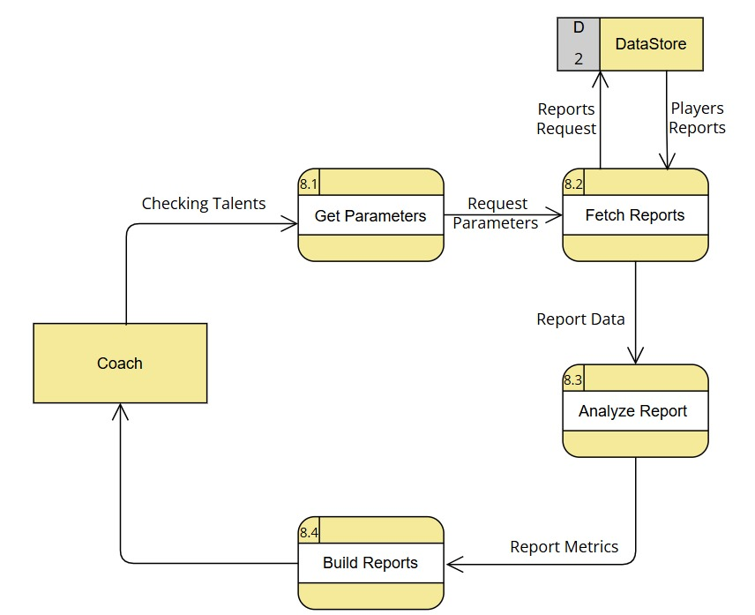

Figure 4.29: DFD Level 1 Diagram

**4.3.4.2.4 Data Dictionary**

**(A) External Entities**

|  |  |
| --- | --- |
| **Entity Name: Player** | **Entity Ref. No.: E1** |
| **Description:**  **A person who interacts with the system to register, log in, upload performance videos, and view reports.** | |
| **Inputs** | **Outputs** |
| **1-Registration Confirmation**  **2- Login Status**  **3-Performance Report** | **1-Registration info**  **2-Login Credentials**  **3-Player video** |

**Table 4.1: Specification for Entity (E1)**

|  |  |
| --- | --- |
| **Entity Name: Coach** | **Entity Ref. No.: E2** |
| **Description:**  **A coach who registers, logs in, and accesses reports to evaluate player performances.** | |
| **Inputs** | **Outputs** |
| |  | | --- | | **1-Coach Registration Confirmation**  **2-Coach Login Status**  **3- Talents Reports** |  |  |  | | --- | --- | |  |  | | |  |  | | --- | --- | | **1-Coach Registration info** |  |   **2-Coach Login Credentials**  **3-Cheking Talents** |

**Table 4.2: Specification for Entity (E2)**

**(B) Processes**

|  |  |  |  |
| --- | --- | --- | --- |
| **Process Name: Save Credentials** | | **Process Ref. No.: P1** | |
| **Description:**  **Stores the registration information of the player in the database and confirms registration status.** | | | |
| **Inputs** | **Logic Summary** | | **Outputs** |
| **1-Registration info**  **2- Registration Status** | **Store data in Users data store** | | **1-Registration Request**  **2-Registration Confirmation** |

**Table 4.1: Specification for Process (P1)**

|  |  |  |  |
| --- | --- | --- | --- |
| **Process Name: Check Credentials** | | **Process Ref. No.: P2** | |
| **Description:**  **Validates the login credentials of the player or coach and returns the login status.** | | | |
| **Inputs** | **Logic Summary** | | **Outputs** |
| **1.Login Credentials**  **2.Login Confirmation** | **Verify credentials from Users data store** | | **1. Login Status**  **2.Login Info** |

**Table 4.2: Specification for Process (P2)**

|  |  |  |  |
| --- | --- | --- | --- |
| **Process Name: Save Coach Credentials** | | **Process Ref. No.: P3** | |
| **Description:**  **Stores the registration information of the coach in the database and confirms registration status.** | | | |
| **Inputs** | **Logic Summary** | | **Outputs** |
| **1. Coach Registration info**  **2.Coach Registration Status** | **Store data in Users data store** | | **1. Coach Registration Confirmation**  **2. Coach Registration Request** |

**Table 4.3: Specification for Process (P3)**

|  |  |  |  |
| --- | --- | --- | --- |
| **Process Name: Check Coach Credentials** | | **Process Ref. No.: P4** | |
| **Description:**  **Validates the login credentials of the coach and returns the login status.** | | | |
| **Inputs** | **Logic Summary** | | **Outputs** |
| **1. Coach Login Credentials**  **2.Coach Login Confirmation** | **Verify credentials from Users data store** | | **1. Coach Login Status**  **2.Coach Login Info** |

**Table 4.4: Specification for Process (P4)**

|  |  |  |  |
| --- | --- | --- | --- |
| **Process Name: Get Player Video** | | **Process Ref. No.: P5** | |
| **Description:**  **Retrieves the video uploaded by the player for analysis.** | | | |
| **Inputs** | **Logic Summary** | | **Outputs** |
| **1. Player video** | **Retrieve and prepare video for processing** | | **1. Processed Data** |

**Table 4.5: Specification for Process (P5)**

|  |  |  |  |
| --- | --- | --- | --- |
| **Process Name: Generate Report** | | **Process Ref. No.: P6** | |
| **Description:**  **Processes the player video to generate a performance report.** | | | |
| **Inputs** | **Logic Summary** | | **Outputs** |
| **1. Processed Data** | **Analyze video data and create report** | | **1. Report Results** |

**Table 4.6: Specification for Process (P6)**

|  |  |  |  |
| --- | --- | --- | --- |
| **Process Name: Show Performance** | | **Process Ref. No.: P7** | |
| **Description:**  **Displays the player's performance based on the processed data.** | | | |
| **Inputs** | **Logic Summary** | | **Outputs** |
| **1. Performance Result** | **Retrieve performance data** | | **1. Performance Report** |

**Table 4.7: Specification for Process (P7)**

|  |  |  |  |
| --- | --- | --- | --- |
| **Process Name: Show Report** | | **Process Ref. No.: P8** | |
| **Description:**  **Displays the generated report to the user (player or coach).** | | | |
| **Inputs** | **Logic Summary** | | **Outputs** |
| 1. **Player Results** 2. **Checking Talents** | **Retrieve report data** | | 1. **Report Request** 2. **Talents Report** |

**Table 4.8: Specification for Process (P8)**

**(C) Data Stores**

|  |  |
| --- | --- |
| **Data Store Name: Users** | **Data Store Ref. No.: D1** |
| **Description:**  **Stores registration and login credentials for both players and coaches.** | |
| **Data Flows IN** | **Data Flows OUT** |
| 1. **Player Registration Request** 2. **Player Login info** 3. **Coach Registration Request** 4. **Coach Login info** | **1. Player Registration Status**  **2. Player Login Confirmation**  **3. Coach Registration Status**  **4. Coach Login Confirmation** |

**Table 4.1: Specification for Data Store (D1)**

|  |  |
| --- | --- |
| **Data Store Name: Reports** | **Data Store Ref. No.: D2** |
| **Description:**  **Stores generated performance reports of players.** | |
| **Data Flows IN** | **Data Flows OUT** |
| 1. **Report Results** 2. **Report Request** | **1. Players Request**  **2.Performance Result** |

**Table 4.2: Specification for Data Store (D2)**

**(D) Data Flows**

|  |  |
| --- | --- |
| **Data Flow Name: Registration Info** | **Data Flow Ref. No.: F1** |
| **Description:**  **Information required for player registration.** | |
| **Source** | **Destination** |
| **Player** | **Save Credentials** |

**Table 4.1: Specification for Data Flow (F1)**

|  |  |
| --- | --- |
| **Data Flow Name: Registration Request** | **Data Flow Ref. No.: F2** |
| **Description:**  **Request to register a new user in the system.** | |
| **Source** | **Destination** |
| **Save Credentials** | **Users** |

**Table 4.2: Specification for Data Flow (F2)**

|  |  |
| --- | --- |
| **Data Flow Name: Registration Status** | **Data Flow Ref. No.: F3** |
| **Description:**  **Confirmation or rejection of registration request** | |
| **Source** | **Destination** |
| **Users** | **Save Credentials** |

**Table 4.3: Specification for Data Flow (F3)**

|  |  |
| --- | --- |
| **Data Flow Name: Registration Confirmation** | **Data Flow Ref. No.: F4** |
| **Description:**  **Notification to player about registration status.** | |
| **Source** | **Destination** |
| **Save Credentials** | **Player** |

**Table 4.4: Specification for Data Flow (F4)**

|  |  |
| --- | --- |
| **Data Flow Name: Login Credentials** | **Data Flow Ref. No.: F5** |
| **Description:**  **Credentials submitted by player for login.** | |
| **Source** | **Destination** |
| **Player** | **Check Credentials** |

**Table 4.5: Specification for Data Flow (F5)**

|  |  |
| --- | --- |
| **Data Flow Name: Login Info** | **Data Flow Ref. No.: F6** |
| **Description:**  **Information to validate login credentials.** | |
| **Source** | **Destination** |
| **Check Credentials** | **Users** |

**Table 4.6: Specification for Data Flow (F6)**

|  |  |
| --- | --- |
| **Data Flow Name: Login Confirmation** | **Data Flow Ref. No.: F7** |
| **Description:**  **Confirmation of login status..** | |
| **Source** | **Destination** |
| **Users** | **Check Credentials** |

**Table 4.7: Specification for Data Flow (F7)**

|  |  |
| --- | --- |
| **Data Flow Name: Login Status** | **Data Flow Ref. No.: F8** |
| **Description:**  **Notification to player about login success or failure.** | |
| **Source** | **Destination** |
| **Check Credentials** | **Player** |

**Table 4.8: Specification for Data Flow (F8)**

|  |  |
| --- | --- |
| **Data Flow Name: Coach Registration Info** | **Data Flow Ref. No.: F9** |
| **Description:**  **Information required for coach registration.** | |
| **Source** | **Destination** |
| **Coach** | **Save Coach Credentials** |

**Table 4.9: Specification for Data Flow (F9)**

|  |  |
| --- | --- |
| **Data Flow Name: Coach Registration Request** | **Data Flow Ref. No.: F10** |
| **Description:**  **Request to register a new coach in the system.** | |
| **Source** | **Destination** |
| **Save Coach Credentials** | **Users** |

**Table 4.10: Specification for Data Flow (F10)**

|  |  |
| --- | --- |
| **Data Flow Name: Coach Registration Status** | **Data Flow Ref. No.: F11** |
| **Description:**  **Confirmation or rejection of coach registration request.** | |
| **Source** | **Destination** |
| **Users** | **Save Coach Credentials** |

**Table 4.11: Specification for Data Flow (F11)**

|  |  |
| --- | --- |
| **Data Flow Name: Coach Registration Confirmation** | **Data Flow Ref. No.: F12** |
| **Description:**  **Notification to coach about registration status.** | |
| **Source** | **Destination** |
| **Save Coach Credentials** | **Coach** |

**Table 4.12: Specification for Data Flow (F12)**

|  |  |
| --- | --- |
| **Data Flow Name: Coach Login Credentials** | **Data Flow Ref. No.: F13** |
| **Description:**  **Credentials submitted by coach for login.** | |
| **Source** | **Destination** |
| **Coach** | **Check Coach Credentials** |

**Table 4.13: Specification for Data Flow (F13)**

|  |  |
| --- | --- |
| **Data Flow Name: Coach Login Info** | **Data Flow Ref. No.: F14** |
| **Description:**  **Information to validate coach login credentials.** | |
| **Source** | **Destination** |
| **Check Coach Credentials** | **Users** |

**Table 4.14: Specification for Data Flow (F14)**

|  |  |
| --- | --- |
| **Data Flow Name: Coach Login Confirmation** | **Data Flow Ref. No.: F15** |
| **Description:**  **Confirmation of coach login status.** | |
| **Source** | **Destination** |
| **Users** | **Check Coach Credentials** |

**Table 4.15: Specification for Data Flow (F15)**

|  |  |
| --- | --- |
| **Data Flow Name: Coach Login Status** | **Data Flow Ref. No.: F16** |
| **Description:**  **Notification to coach about login success or failure.** | |
| **Source** | **Destination** |
| **Check Coach Credentials** | **Coach** |

**Table 4.16: Specification for Data Flow (F16)**

|  |  |
| --- | --- |
| **Data Flow Name: Player Video** | **Data Flow Ref. No.: F17** |
| **Description:**  **Video submitted by player for performance analysis..** | |
| **Source** | **Destination** |
| **Player** | **Get Player Video** |

**Table 4.17: Specification for Data Flow (F17)**

|  |  |
| --- | --- |
| **Data Flow Name: Processed Data** | **Data Flow Ref. No.: F18** |
| **Description:**  **Data processed from player video.** | |
| **Source** | **Destination** |
| **Get Player Video** | **Generate Report** |

**Table 4.18: Specification for Data Flow (F18)**

|  |  |
| --- | --- |
| **Data Flow Name: Report Results** | **Data Flow Ref. No.: F19** |
| **Description:**  **Results from performance analysis.** | |
| **Source** | **Destination** |
| **Generate Report** | **Reports** |

**Table 4.19: Specification for Data Flow (F19)**

|  |  |
| --- | --- |
| **Data Flow Name: Performance Result** | **Data Flow Ref. No.: F20** |
| **Description:**  **Performance analysis result for player.** | |
| **Source** | **Destination** |
| **Reports** | **Show Performance** |

**Table 4.20: Specification for Data Flow (F20)**

|  |  |
| --- | --- |
| **Data Flow Name: Performance Report** | **Data Flow Ref. No.: F21** |
| **Description:**  **Report on player’s performance.** | |
| **Source** | **Destination** |
| **Show Performance** | **Player** |

**Table 4.21: Specification for Data Flow (F21)**

|  |  |
| --- | --- |
| **Data Flow Name: Reports Request** | **Data Flow Ref. No.: F22** |
| **Description:**  **Request for player performance reports.** | |
| **Source** | **Destination** |
| **Coach** | **Reports** |

**Table 4.22: Specification for Data Flow (F22)**

|  |  |
| --- | --- |
| **Data Flow Name: Talents Reports** | **Data Flow Ref. No.: F23** |
| **Description:**  **Reports on identified talents.** | |
| **Source** | **Destination** |
| **Reports** | **Coach** |

**Table 4.23: Specification for Data Flow (F23)**

|  |  |
| --- | --- |
| **Data Flow Name: Checking Talents** | **Data Flow Ref. No.: F24** |
| **Description:**  **Request to view talent reports.** | |
| **Source** | **Destination** |
| **Coach** | **Show Report** |

**Table 4.24: Specification for Data Flow (F24)**

|  |  |
| --- | --- |
| **Data Flow Name: Report Results** | **Data Flow Ref. No.: F25** |
| **Description:**  **Displayed results of talent reports.** | |
| **Source** | **Destination** |
| **Show Report** | **Coach** |

**Table 4.23: Specification for Data Flow (F23)**

**4.3.5 Data Modeling**

**4.3.5.1 Database Schema**

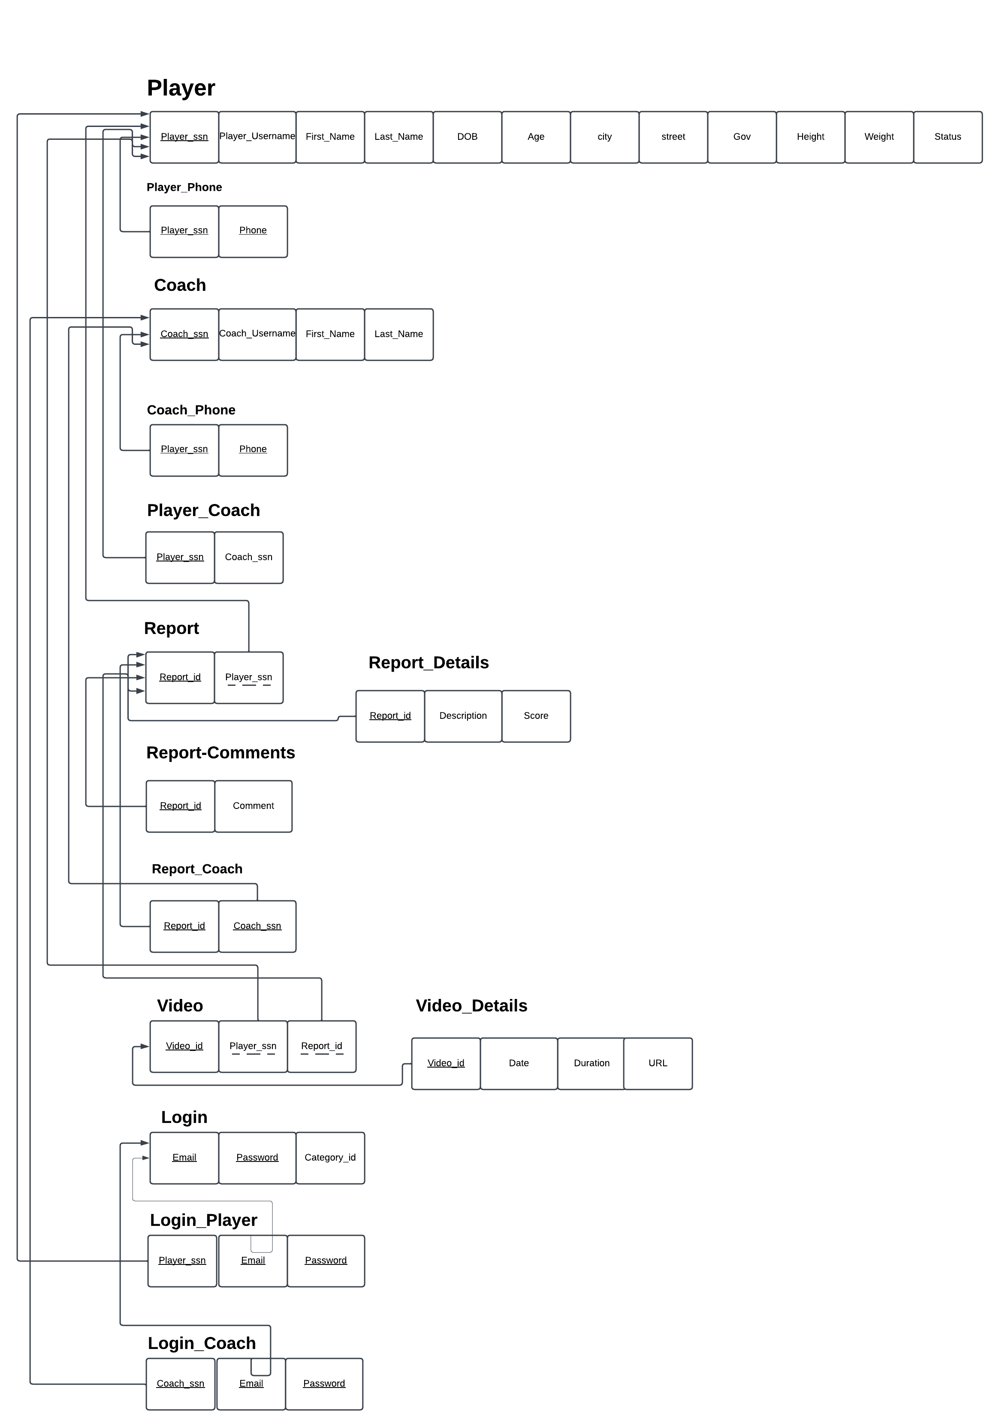

Figure 4.30: Database Schema

**4.3.5.1 Entity-Relationship Diagram**

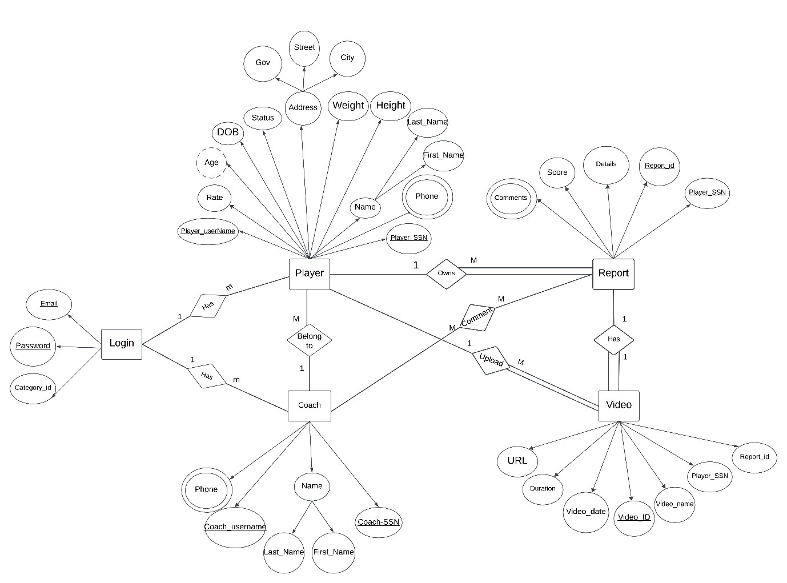

Figure 4.31: entity relationship diagram

Figure 4.21: Database Schema

**4.4 System Architecture**

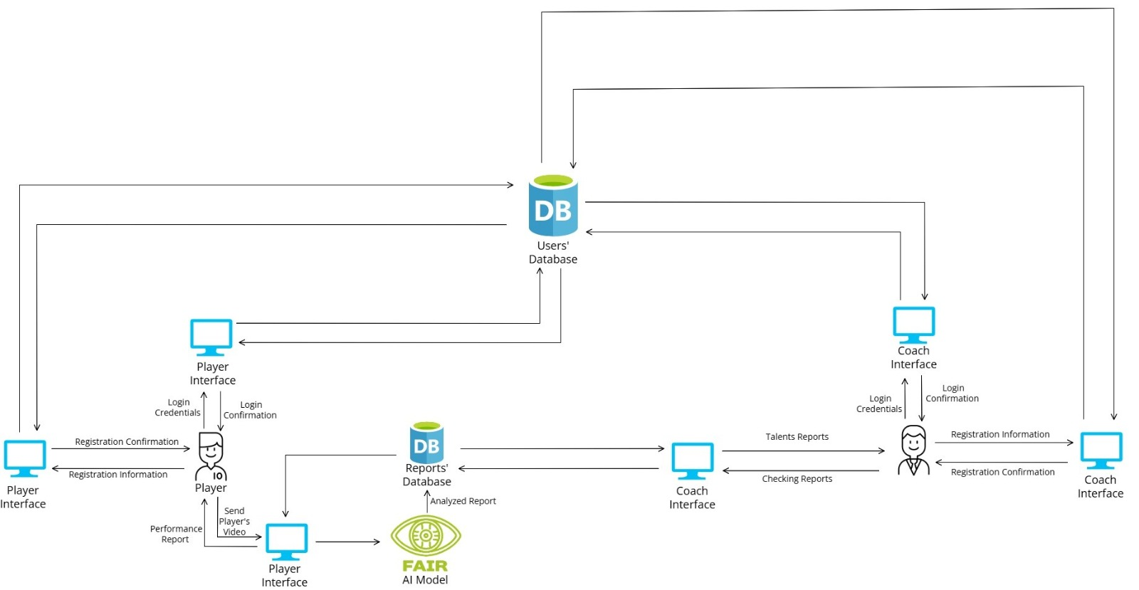

Figure 4.32: System Architecture

**4.5 UI/UX Design**

[Link For our Figma Design](https://www.figma.com/design/J3GvtNioYMCVa6G3svX1N2/Project_Design?node-id=0-1&t=0AhxZfisC2t1pBGa-1)

Figure 4.33: UI/UX Design